UNIVERSITY OF WAH (UOW)

DEPARTMENT OF COMPUTER SCIENCE



BSCS 3RD B

REG #: UW-24-CS-BS-088

SUBMITTED BY: SAADI SAFDAR

SUBMITTED TO: SIR. HASSAN SHAFAQAT

COURSE TITLE: COMPUTER NETWORKS

COURSE CODE: CS – 241 L

OPEN ENDED LAB

Q1:
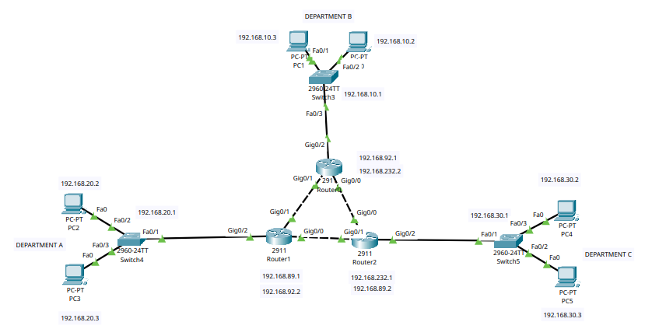
PCs ip addressing:

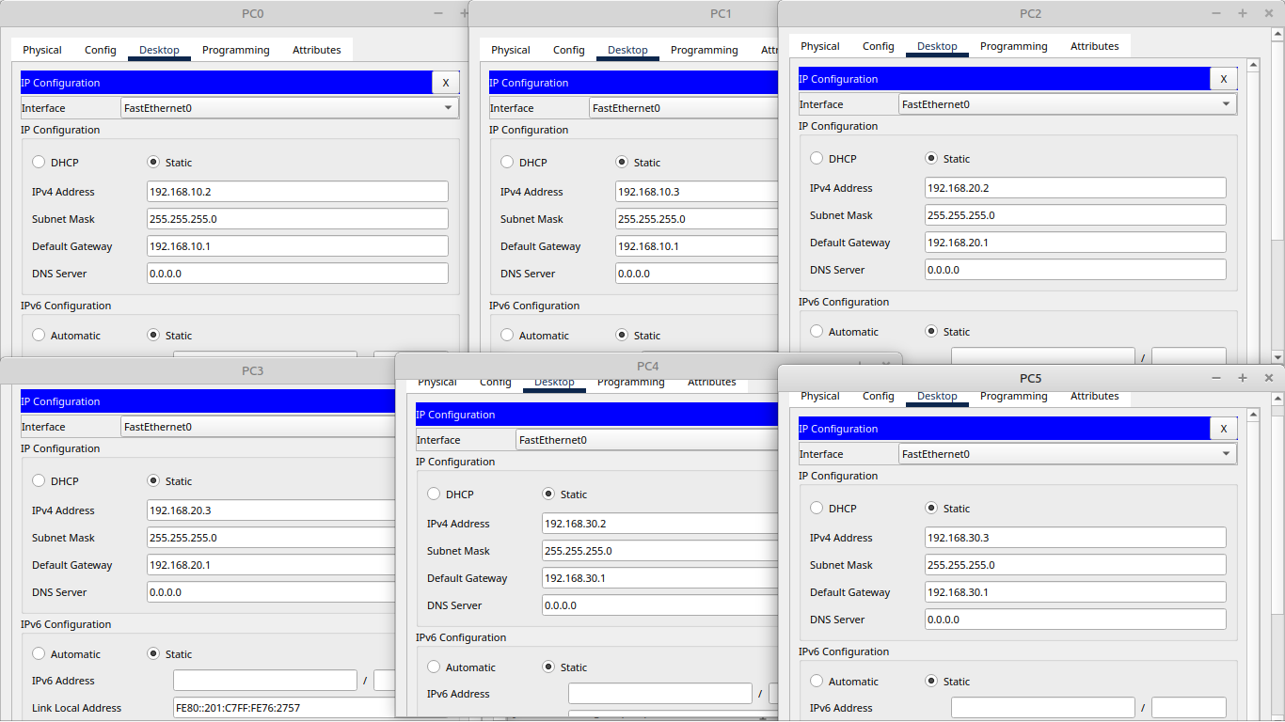

GigabitEthernet 0/0 ip addressing in Routers:

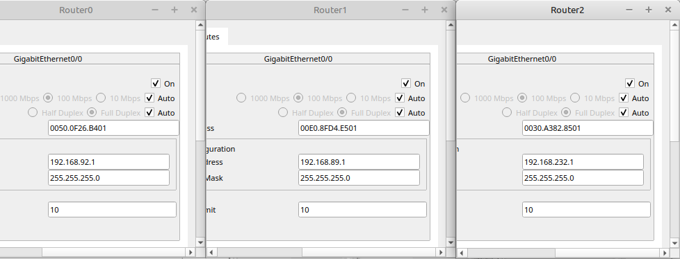
GigabitEthernet 0/1 ip addressing in Routers:

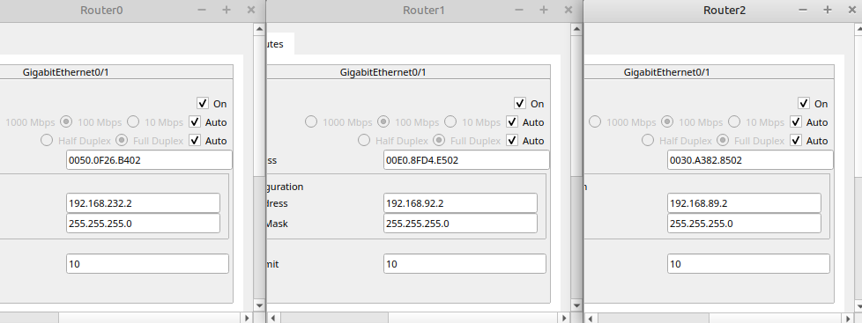
GigabitEthernet 0/2 ip addressing in Routers:
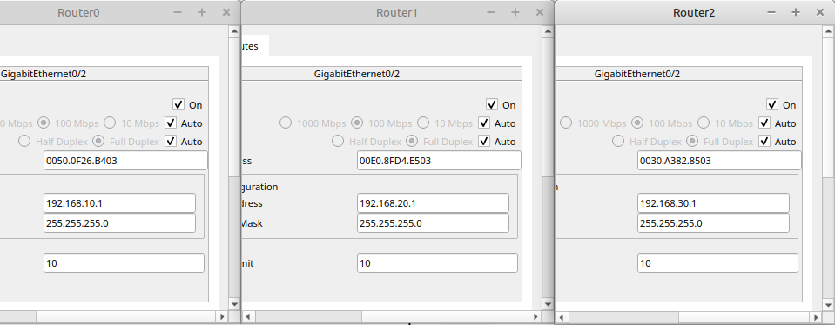
Successfull pings among departments A, B, and C:
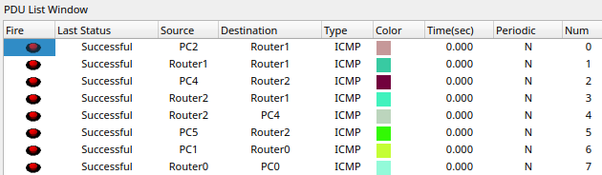
Q2:

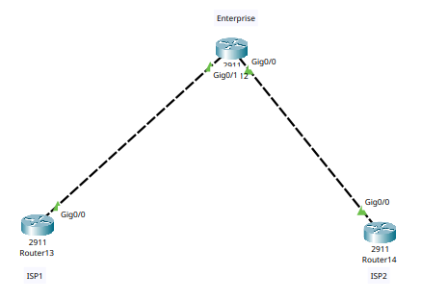

Enterprise router:
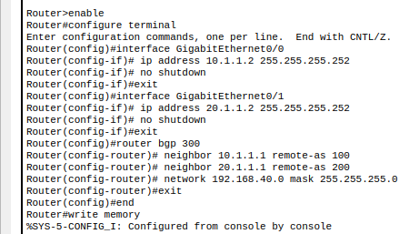

ISP 1 router:
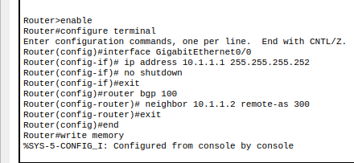
ISP 2 router:

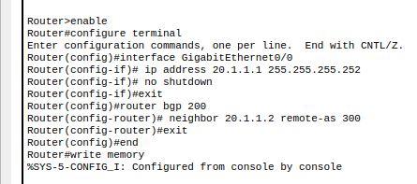
IPs Working:

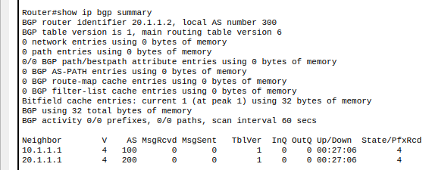

Q 3:
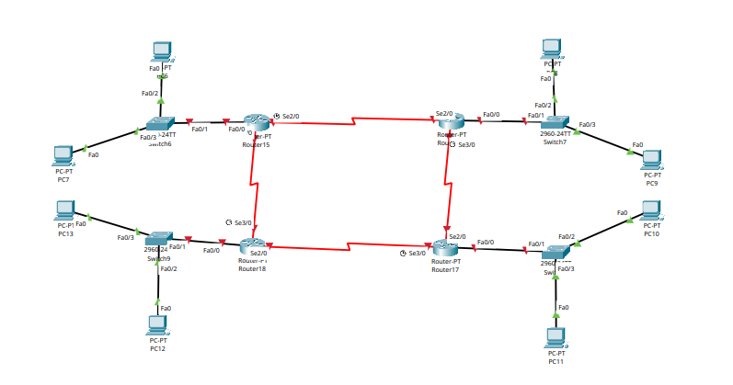
Router’s IP Adrressing:
Serial 2/0:
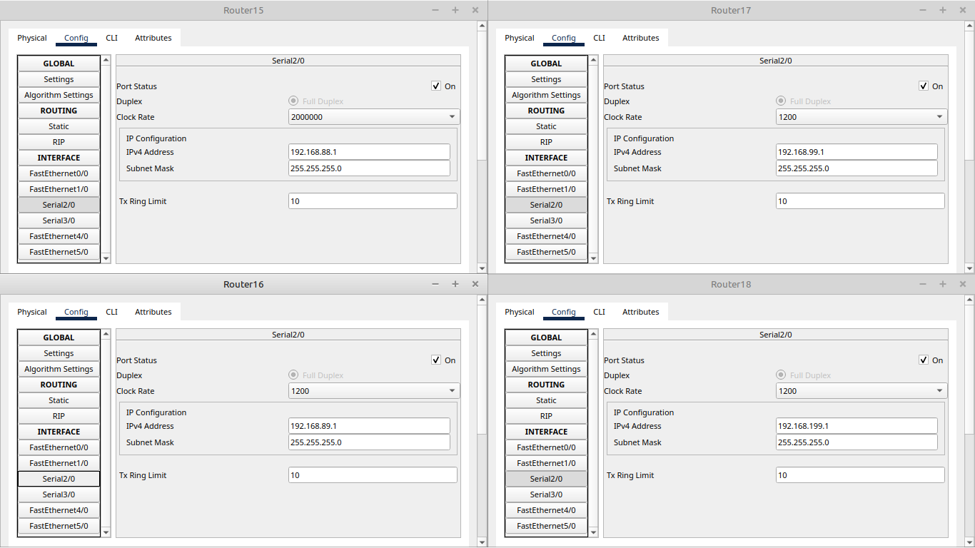
Serial 3/0:
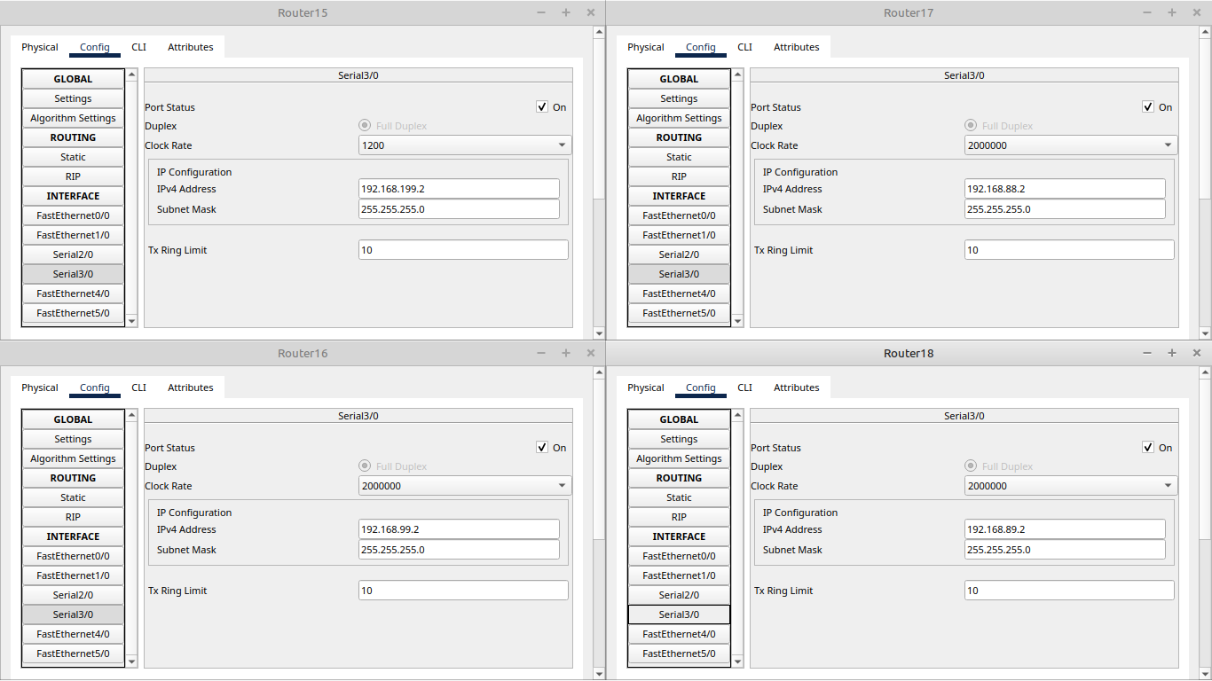
FastEthernet 0/0:
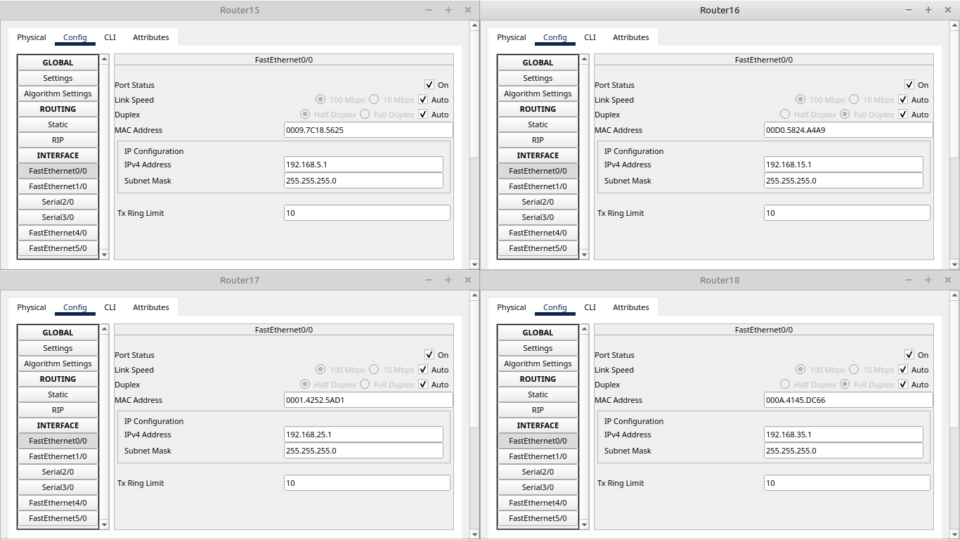

RIPs:
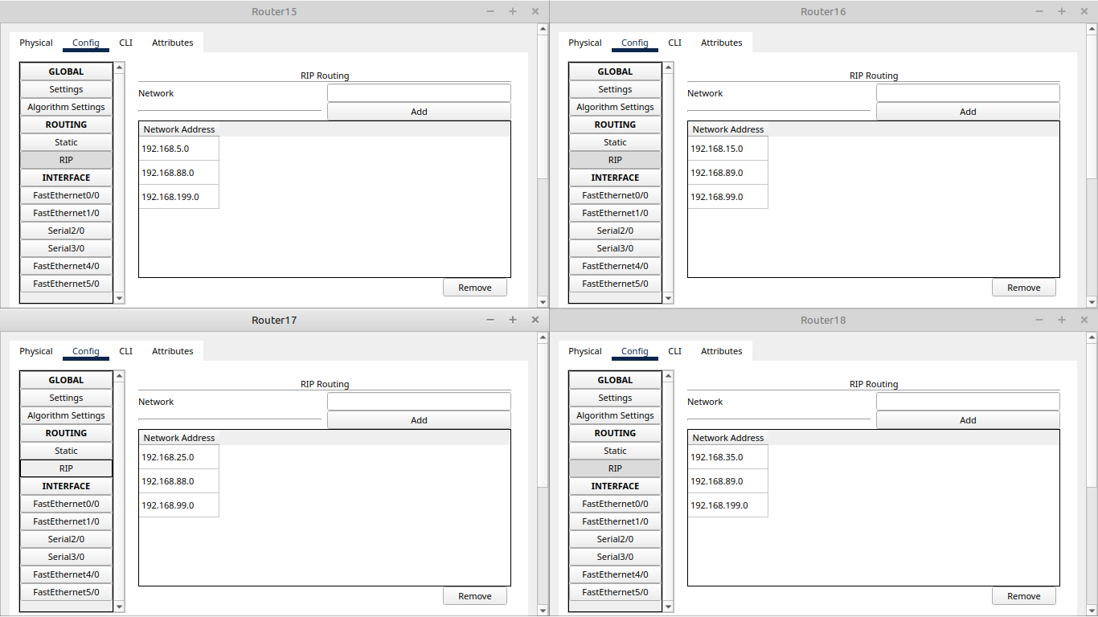
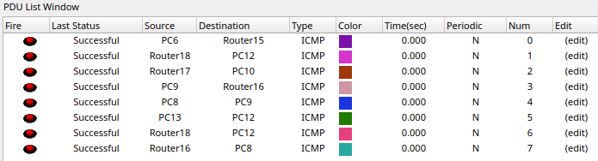
Successful pings:

